
Company
Logotype

Cone Beam Computed Tomography- Report



Porur Dental X-rays & CBCT

Patient Name : Mr. Sathish Kumar | Date of Report : 12.07.2024
Age/ Gender : 41 years/ Male | Region of Interest : CBCT Sectional Mandible
Referring doctor: Dr. S. Karthick | Indication : Impacted tooth
Clinical Notes: Nil
PATIENT INFORMATION

CBCT Sectional Mandible provided
CBCT – IMAGE DETAILS

RADIOGRAPHIC INTERPRETATION

- In relation to 31, 32 region, presence of impacted 33 between the radicular portion of 31 and 32. This occlusal plane of this tooth appears to be in line with the middle third of the root of 32.
- Distance between the root tip of 33 and the lower border of mandible: 4.08 mm
- The impacted tooth 33 appears to be labially placed causing thinning of the labial cortical bone. The tooth 33 also appears to be involving the radicular portion of 32 and 31.
- In relation to 42, presence of hyperdense restorative material involving the pulp canal upto the apical third of the root is evident.

RADIOGRAPHIC IMPRESSION


- Impacted tooth: 33
- Root canal treated with crown: 42

IMAGES FOR REFERENCE

RECONSTRUCTED PANORAMIC VIEW
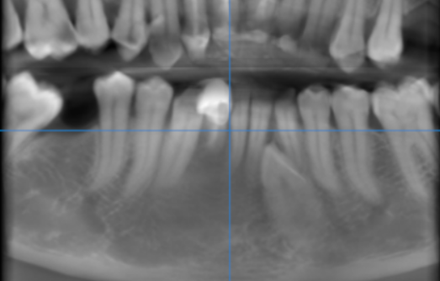

3-DIMENSIONAL VIEW
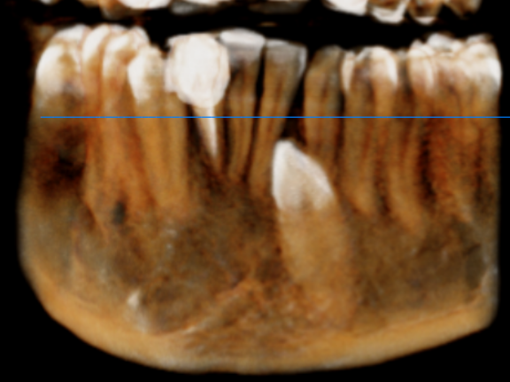

CROSS- SECTIONAL IMAGES
33 REGION | 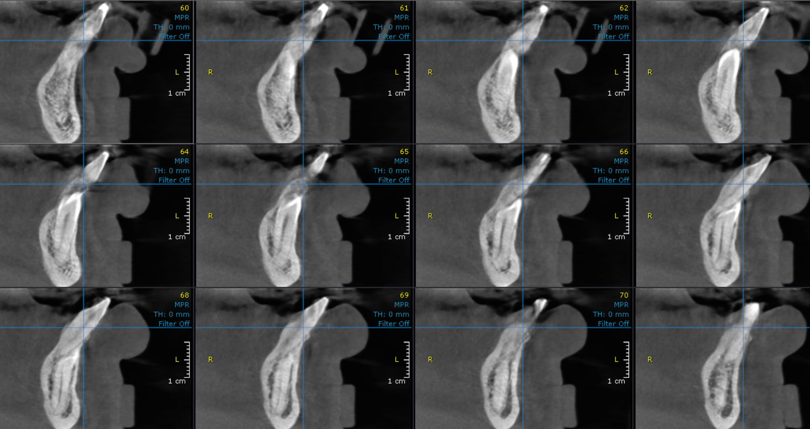

**** End of report ****

